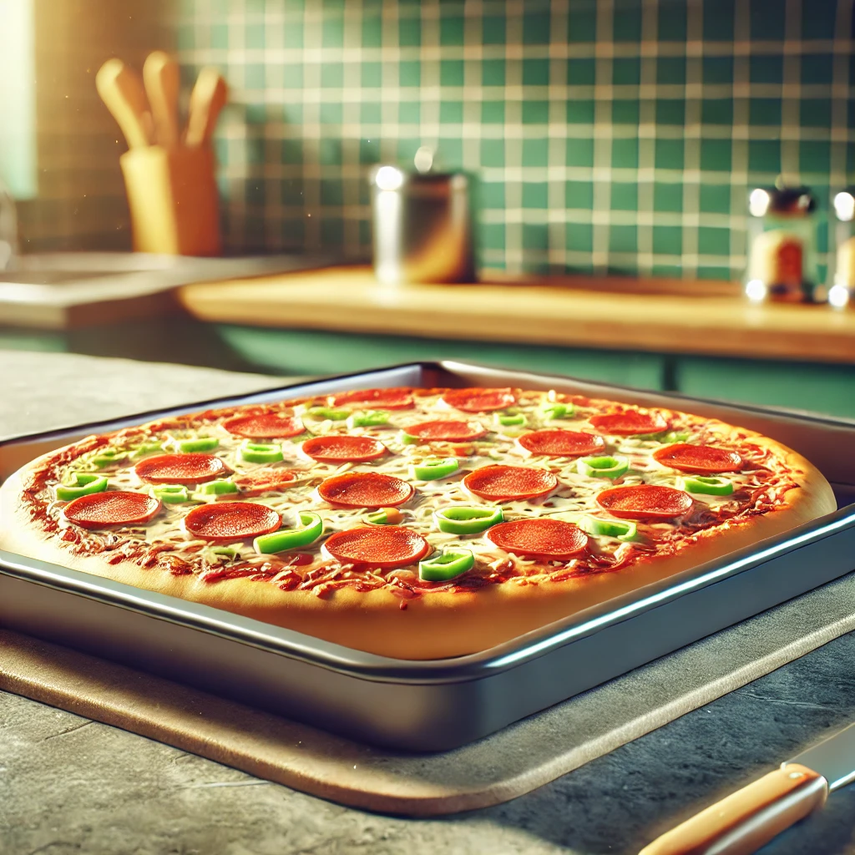

For me the scene I was attempting to replicate is the above one, I will admit I didn’t include every object in the scene however I tried to capture it in a way that it was clear I was trying to replicate such. For example I decided to skip the spoons in the background that are located inside a holder; or are they knives? It’s hard to tell, anyways I skipped them due to them seeming irrelevant as I was trying to focus on the pizza more than anything, so the pizza was the centerpiece.

I decided to go with somewhat realistic textures however not quite realistic shapes for some things- Such as the peppers, they are just green circles, that is due to not quite knowing how I would go about making malformed shapes such as pepper slices. For other things I decided to choose different variants such as different colored counter-tops and the like in order to better contrast against the darkness in the background. I also tried to make sure each object stood out from one another rather than all blending in, as such one countertop is granite and the other one is wood.